**Tolls Gameplay:**

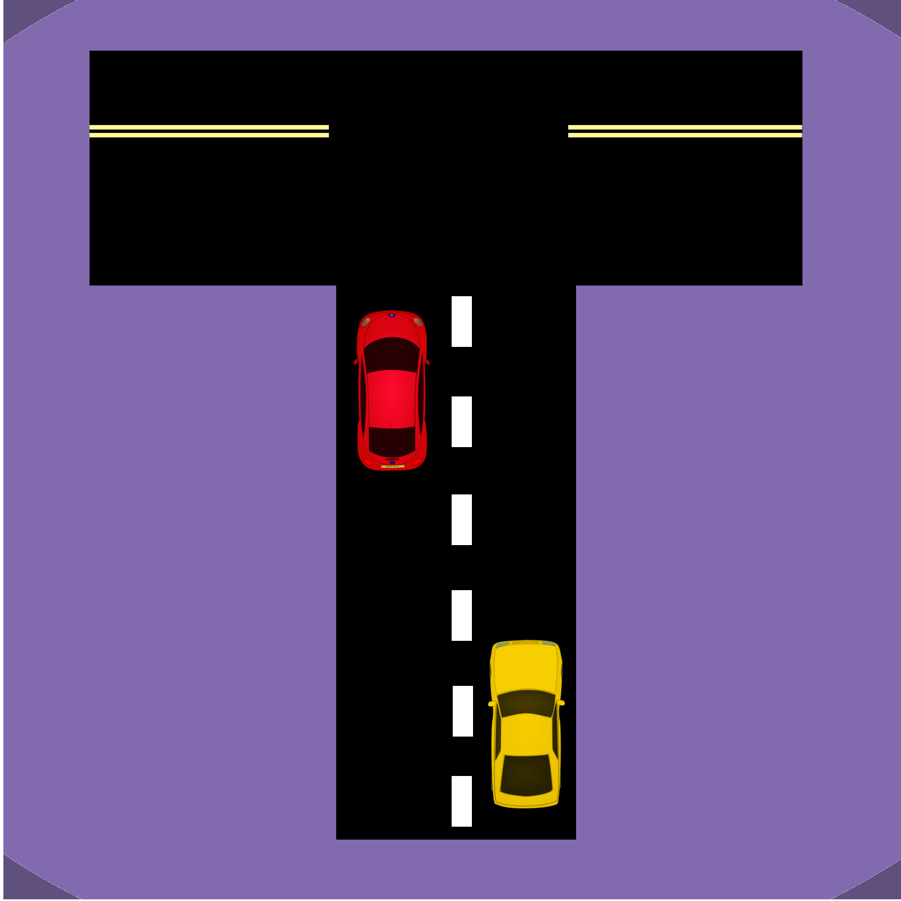

**Contents:**

|  |
| --- |
| Summary: |
| Quick Start Guide: |
| Rules: |
| Rolling and Moving |
| Buying and Owning Properties |
| Toll Tile, Detours and Service Station |
| Losing and Winning |

**Summary:**

Tolls the board game offers an exciting and dynamic experience, utilising real time traffic data to incur penalties when landing on other players roads. This is taken from transport NSW’s Roads Real-Time data set.

**Quick Start Guide:**

This section will take you through a quick round of Tolls. Use this section if you don’t want to do a lot of reading and get into the fun as soon as possible!

**Start:**  
To start decide the turn order first, usually by each player rolling a die, the player with the highest die result gets to go first.

Then you need to load up your client, this should be preconfigured with your server’s IP Address details, and your server will need your IP Address details.

Start by selecting the roll die and move option on your client. This will allow you to move your player around the board!

You will now have the option of buying a road! Buy that road!

Looks like you bought High Street, Penrith! Good job!

Now end your turn.

**Second Players Turn:**

Roll your Dice just like the first player!

If you land on a property it would be best to purchase it!

However if you happen to land on player ones property expect to pay for the tolls he has on it! This will be done automatically and the cost will be taken from how long expected travel time is on that road at the current time.

**Third Players Turn:**

Roll those dice!  
You happened to land on the Detour tile! This means you get randomly put on another detour tile on the board. The game will automatically do this for you so don’t worry! Maybe you will be put closer towards the end and get to collect the sweet prize money for passing the service station!

**Rest of the Game:**Now for the rest of the game continue, but remember some important details:  
You can only trade players once a turn! And no modifying trades, first time offer or nothing.  
Once you pass the service station collect 100 dollars.

**Rules:**

**Rolling and Moving:**Rolling and moving is all controlled by the program, all you need to do is select the option, and however this section will explain the mechanics of what is happening and the reasoning behind it.  
**Rolling:**   
When you select the Roll and move option the first thing the server does is calculate your roll for you. This is decided by rolling two six-sided die.  
**Moving:**When you roll the die the program automatically moves you around the board, it does that by moving however many positions from where the player is depending on the dice roll earlier.  
Depending where you land a couple of this can happen:  
 **Road:**   
You landing on a road! If this is road is not owned you can have the chance to purchase it, see the buying and owning properties section for this.  
However, if this road is owned you have to pay a fee for accessing it as the player has set up Tolls! The computer will automatically charge you for this but know that it is taken from current travel time along the road you landed on.   
Pay the player the money and end your turn!  
 **Detour:**You landed on a detour tile, now what? Well the detour tile randomly moves you to another detour tile on the board, this can help if you are trying to get away from a players high traffic road or hurt you if you are trying to get to a high value non-owned road.  
 **Service Station:**You landed or passed the service station! This means you collect 100 dollars! Then move on with your turn.

**Buying and Owning Properties:  
Buying:**When you land on a property you have the option to buy it. The computer manages this for you but the way it works is, you pay the cost of the property which comes out of your wallet. You start with 500 dollars.  
**Owning:**  
When you own a road you put your tolls on it and earn money when other players land on it according to how long travel times are along your road in real-time and real-life.  
When another player lands on your road they will have to pay you!  
**Upgrading Roads:**  
When you own a road you have the opportunity to upgrade it on your turn. This will cost some money and mean the road will be in upgrade mode for a few turns. However will mean you get increased money when a player lands on it in the future.

**Toll Tile, Detours and Service Station:**

**Toll Tile:**When you land on the toll tile you have to pay a percentage of your current wallet to the government. This cost is taken by the game round X 2.5; this is the percentage of money paid to the government when you land on the tile. **Detours:**When you land on the detour tile you get randomly placed at another detour tile, you then complete your next turn starting from this new detour tile.  
**Service Station:**   
When you pass or land on the service station collect 100 dollars.

**Losing and Winning:**

When you run out of money you lose! If you are the last person standing you win!